**INTERVIEW QUESTIONS!!! Go over this again (it was given in the pre-work) and make sure you practice frequently with your newfound knowledge!**

**https://www.gitbook.com/read/book/the-coding-bootcamp/whiteboarding-algorithms-and-interview-questions?key=technicalInterview**

**=== is also compare type like string= must be string**

**== is compare without type to sting is 0 and int is 0 also can be true…**

* **What Is most selling product in Walmart?**
  + Milk
  + Toilet paper
  + Bread
  + Candies
  + Alcohol
  + **Banana is right answer!!!!! (cheap and comes as u enter in stores)**
* **51 cards if missing one how can u find faster?**
  + 4 array of 4 kind and checking all by index 0 to 14 like
  + H-0 n s-0 n D-0 n C-0 is there or not +1 in loops n check
  + Other way go by suits kind of 4 and check all 13 there or not!!
* **1-100 script that prints that number in console and if number divided by 5 then print buzz and if number if divided by three and five then print fizz buzz**
  + for (var i=1; i<=100; i++)

{

if ((i%3===0) && (i%5===0)) or **if (I %15===0)**

{console.log ("Fizz Buzz");

}

else if (I % 5=== 0)

{console.log("buzz");

}

else if (i% 3===0)

{

console.log("Fizz");

}

else

{console.log (i);

}

}

* find Prime number ( largest prime is **277,232,917** – 1 with **23,249,425 digits**)

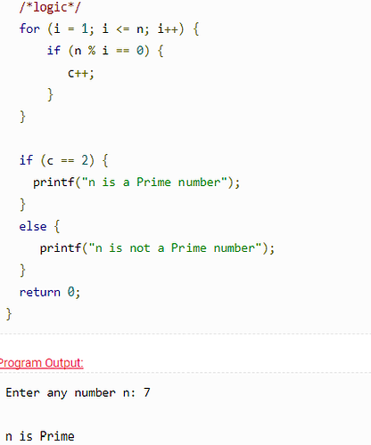

* **Algorithms** –
  + <https://www.quora.com/What-is-the-difference-between-algorithm-and-programming>
  + **Algorithm** is solving the problem in a generic logical language. An algorithm is focused more on general human understanding and sits at a higher abstract level, that unites all computer programming languages. A problem could have the same algorithm, but 10 different implementations in 10 different programming languages.
  + **Programming** is implementing the already solved problem (algorithm) in a specific computer language where syntax and other relevant parameters are different, based on different programming languages.
  + ***Algorithm*** is a set of instructions that solve a given problem. The computer may or (mostly)may not understand the language used for writing the algorithm(usually pseudo-code or English).  
      
    ***Programming*** is transferring the content of the algorithm into a language the computer understands so that you can ask the computer to implement the algorithm.

**Computer Algorithm:**

To make a [computer](https://computer.howstuffworks.com/pc.htm) do anything, you have to write a [computer program](https://computer.howstuffworks.com/program.htm). To write a computer program, you have to tell the computer, step by step, exactly what you want it to do. The computer then "executes" the program, following each step mechanically, to accomplish the end goal.

When you are telling the computer *what* to do, you also get to choose *how* it's going to do it. That's where **computer algorithms** come in. The algorithm is the basic technique used to get the job done. Let's follow an example to help get an understanding of the algorithm concept.

* **Bubble sort algorithm (and program)**

function bubbleSort(x) {

var a = x;

var count = 0;

var swap = false;

while (!swap) {

for (i = 0; i < a.length - 1; i++) {

if (a[i] > a[i+1]) {

var y = a[i];

var z = a[i+1];

a[i]= z;

a[i+1] = y;

}

else {

count++;

}

}

if (count === (a.length - 1)) swap = true;

}

return a;

}